

Department of Computer Science & Information Technology

III Year,V Semester(Batch 2022-2026)
Lab Record Submission of

Linux (Lab)
Subject Code – CSIT-505

Submitted to: Submitted by:
Prof. Nidhi Nigam Tanishka Soni
0827CI221135

Overview of the Linux File System
Introduction
The Linux file system is a crucial component of the Linux operating system, responsible for organizing and managing data on disk drives. Unlike other operating systems, Linux employs a unique hierarchical structure that helps maintain file organization and accessibility.
File System Structure
1. Root Directory (/)
At the top of the Linux file system hierarchy is the root directory, denoted by /. All other files and directories are organized beneath this root.
2. Key Directories
- /bin: Essential command binaries. Contains fundamental command-line utilities like ls, cp, and mv.
- /boot: Contains boot loader files and the Linux kernel. This is crucial for the system startup process.
- /dev: Device files that represent hardware components. For example, /dev/sda refers to the first hard disk.
- /etc: Configuration files for system and application settings. This includes user account information, network configurations, and more.
- /home: User home directories. Each user has a subdirectory here, such as /home/username.
- /lib: Essential shared libraries and kernel modules required by system binaries.
- /media: Mount points for removable media like USB drives and CDs.
- /mnt: Temporary mount points for mounting file systems.
- /opt: Optional application software packages.
- /srv: Data for services provided by the system, such as web or FTP servers.
- /tmp: Temporary files created by users and applications. This directory is often cleared on reboot.
- /usr: User-related programs and data. It contains subdirectories like /usr/bin for user commands and /usr/lib for libraries.
- /var: Variable files like logs and databases that change in size and content.
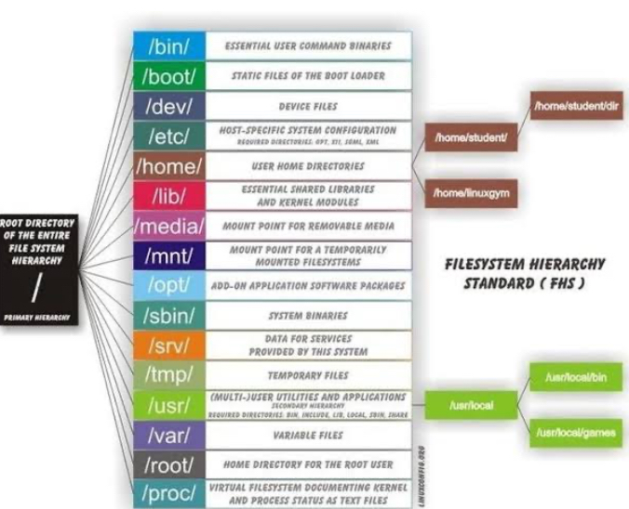
Figure 1Linux file system
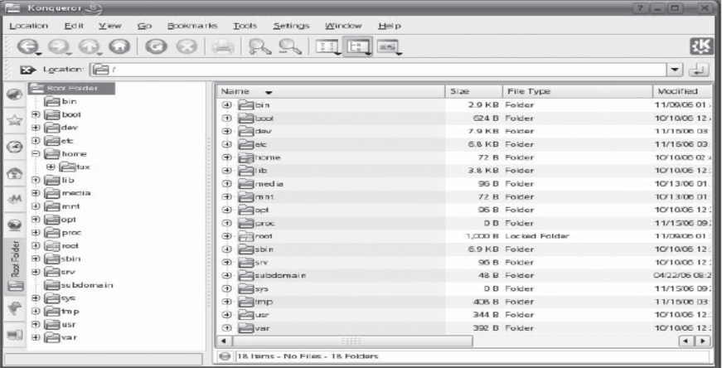
Figure 2linux file system (b)
File Types
Linux supports several types of files, including:
- Regular files: Contains user data.
- Directories: Special files that contain lists of other files and directories.
- Special files: Includes device files and named pipes.
- Symbolic links: Pointers to other files or directories.
File Permissions
Linux implements a robust permission system to enhance security. Each file and directory has associated permissions that dictate access levels:
- Owner: The user who owns the file.
- Group: A set of users that have shared access to the file.
- Others: All other users on the system.
Permission Types
- Read (r): Permission to read the file.
- Write (w): Permission to modify the file.
- Execute (x): Permission to execute a file (for scripts and programs).
Permissions are represented in a three-character string format, such as rwxr-xr--, where the first three characters represent owner permissions, the next three represent group permissions, and the last three represent permissions for others.
Mounting File Systems
Linux allows multiple file systems to be mounted at different points in the directory tree. The mount command is used to attach file systems. For example:
bash
Common File System Types
Linux supports various file system types, including:
- ext4: The most common file system used in modern Linux distributions, known for its performance and reliability.
- XFS: A high-performance file system suitable for large-scale data storage.
- Btrfs: A newer file system designed for advanced features like snapshotting and dynamic resizing.
- FAT32/exFAT: Used primarily for removable media due to broad compatibility.

THANK YOU !!!

